1- [20 pts] Provide a short answer to the following questions.

1. 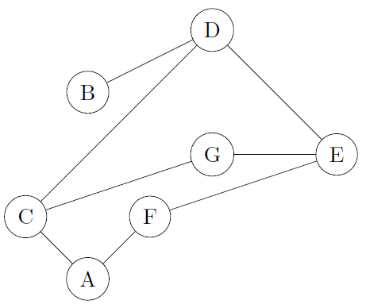Give a formal definition for the following graph:

(b) Draw the graph, given by the following formal definition:

*G* = (*V, A*)

*V* = *{a, b, c, d, e}*

*A* = *{*(*a, c*)*,* (*b, c*)*,* (*c, a*)*,* (*c, d*)*,* (*d, b*)*,* (*d, e*)*,* (*e, a*)*,* (*b, a*)*}*

(c) What is one quality that *all* trees exhibit, that graphs, in general, do not?

(d) What is collision in hashing? What are the general two ways to resolve collisions?

1. What is hashing good for?

2-

1. Given the following adjacency matrix, draw the weighted, undirected graph with

*V* = *{v0, v1, v2, v3, v5 }*.

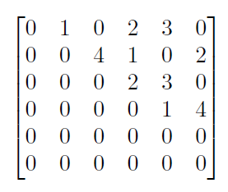

1. What is a topological sort for this graph?

**3- Use Kruskal’s Algorithm to calculate the minimum spanning forest of the following graph *G* = (*V, E, w*). Show all steps. List all vertices in a particular spanning tree, and give its final cost.

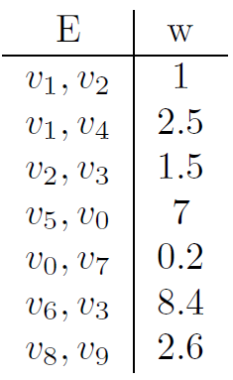

Given the graph *G* = (*V, E, w*), below, find the shortest path between *v*0 and *v*6.

*V* = *{v0, v1, v2, v3, v5 , v6, v7 }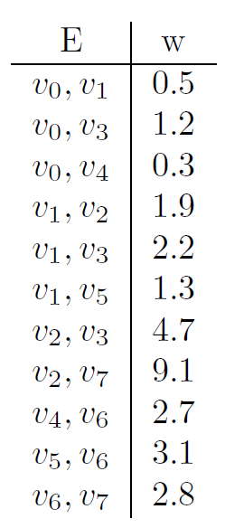*

Use *Djikstra’s algorithm* to find all-pairs shortest paths from *v*0 to vertices in its connected component in the following graph.

*V* = *{v0, v1, v2, v3, v5 , v6, v7 }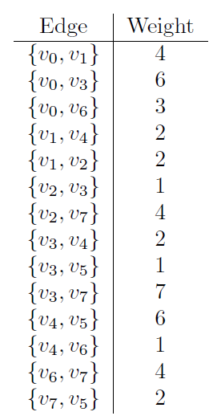*

Build a *Hash Table* of size 8 by inserting the following values in order. Use the algorithm provided to calculate hash values, and open addressing to resolve all collisions. Show all intermediate tables, include both the value and its index in your illustrations.

12, 456, 137, 10907, 1144, 953, 4, 3713

int hash (int input) { int h = input  10;

h += (input / 10)  10;

return h  8;

}

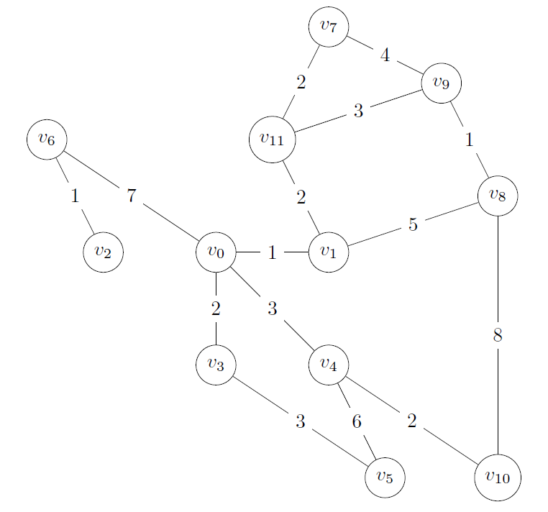Use Kruskal’s algorithm to construct a minimum spanning forest for the following graph. Yes, you may the draw graphs. Show all steps.

****Question 5 (20 Points)** Use Kruskal’s Algorithm to calculate the minimum spanning forest of the following graph *G* = (*V, E, w*). Show all steps. List all vertices in a particular spanning tree, and give its final cost.

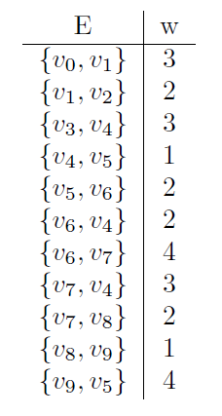

****Question 7 (20 Points)** Given the graph *G* = (*V, E, w*), below, find the shortest path between *v*2 and *v*6. Show all steps.

